

Transcatheter Mitral Valve Repair. Mitraclip Procedure

Patient Information Sheet

You have been found to have a condition called mitral regurgitation, and your doctors are considering treating this by a procedure to repair the mitral valve using a trans-catheter technique called Mitraclip.
In this leaflet we explain some of the aims, benefits, risks and alternatives to this procedure. We want you to be fully informed about the procedure and your choices so that you can be involved in making any decisions.
Please ask about anything you do not fully understand or wish to have explained in more detail.
If you would like this information in another format or language or would like help, please ask a member of our staff.

What is mitral regurgitation?
You have a heart valve condition called mitral regurgitation.
The mitral valve is one of the four heart valves that control the flow of blood in and out of the heart. If the valve becomes abnormally leaky (mitral regurgitation) the heart must work harder to pump the same amount of blood, so the work for the ventricle (pumping chamber) increases. As a result the chambers of the heart enlarge.

Mitral regurgitation gets worse with time. Medications can sometimes slow the progression. Symptoms may not be apparent immediately because the heart will compensate for the extra volume caused by the leaking valve. But, ultimately, the extra strain on the heart will result it becoming weaker. Without surgery, patients with severe symptomatic mitral regurgitation have a poor prognosis with an annual mortality rate of 5% per year.
Until now heart valve repair has involved open-heart surgery. As your doctor will have explained, we believe you may be at high risk or have some contra-indications for this surgery.
However, you may be suitable for another form of valve repair, one which does not require open heart surgery. Instead, the valve is repaired percutaneously (“through the skin”) via the groin using a catheter (thin flexible tube). This method does not require the breast bone to be cut or open heart surgery to be performed. At the moment this type of treatment is only appropriate for certain patients.

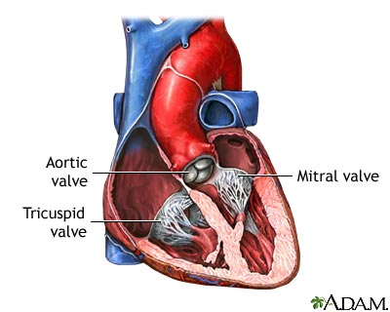
Mitral regurgitation can cause shortness of breath and palpitations including atrial fibrillation.

What will happen to me before the procedure?
Before you have your valve repair procedure, we will carry out a number of tests to find out as much as we can about your heart and so help us carry out the valve repair effectively. As well as routine blood tests, you may have an angiogram (when a catheter is placed into an artery in your leg and x-ray pictures are taken of your heart and arteries), an echocardiogram (an ultrasound of your heart), and trans-oesophageal echocardiogram (further details given below in the next paragraph) to get a more detailed assessment of your valve problem, a magnetic resonance imaging scan (MRI scan – which uses magnetic and radio waves to create pictures of your heart) and a lung function test to see how well your lungs are working.

We will explain any tests to you in full and you may, of course, ask any questions.

What will happen during the procedure?
Transcatheter valve repair is carried out in the cardiac catheterisation laboratory under general anaesthetic. Once you are asleep, we will pass a trans-oesophageal echo (TOE) probe into your oesophagus (also known as your gullet or “food pipe”). A TOE is a special type of ultrasound that uses sound waves to take very clear pictures of the heart. This allows your cardiologist to use TOE to guide the catheters into place in your heart.

We first make a small incision (cut) in your groin and then, through the incision, insert a small tube. Through this tube we insert a catheter. Using x-ray pictures, we then guide this catheter into your heart. To access your mitral valve a small puncture is made in the interatrial septum, the thin wall between the 2 collecting chambers in the heart. Once the catheter is in place we can deliver the MitraClip into position to repair the leak of the mitral valve. Some patients may require more than one clip to adequately repair the valve.

Some patients need a blood transfusion during the procedure. Please let us know if you have any objections to having a transfusion.

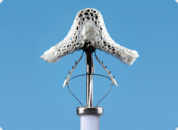
The MitraClip is made of metal with a polyester fabric coating. It has a delivery system that allows the device to be manipulated into position, and if necessary repositioned, before final release. If required, a second MitraClip can be performed at the same procedure.
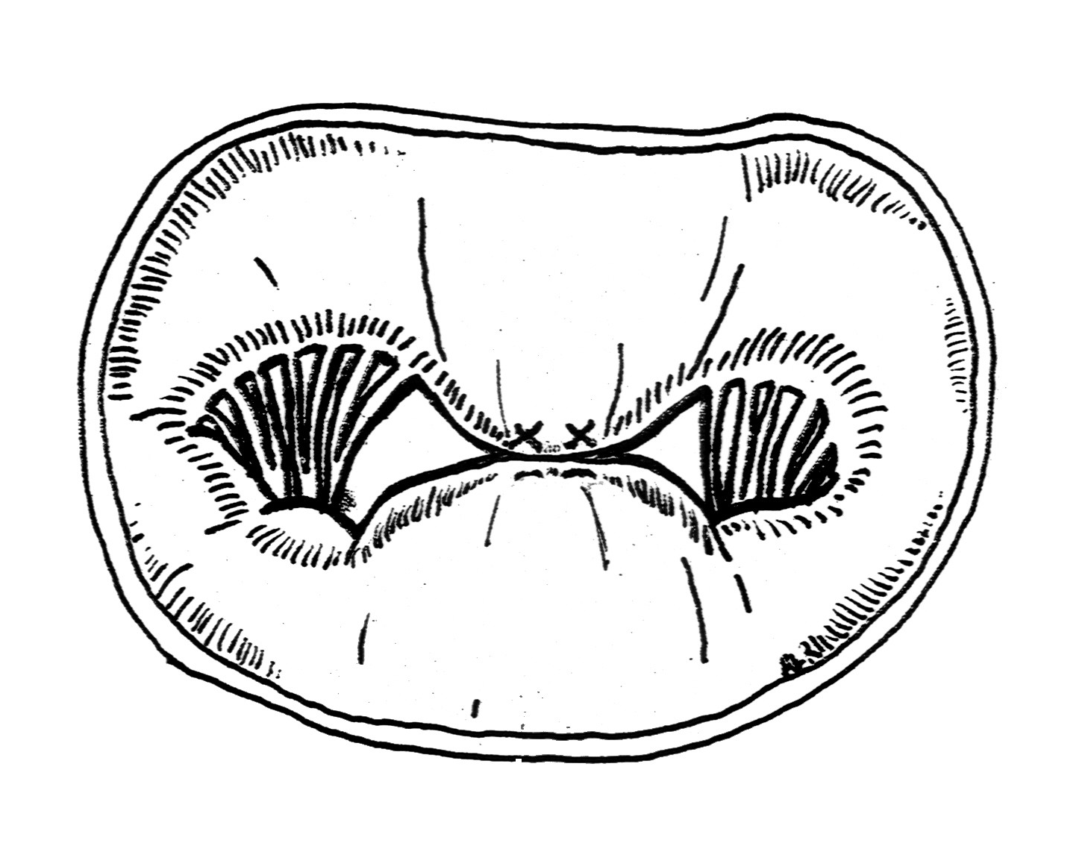

The MitraClip pulls the centre of the mitral valve leaflets together. This reduces the extent of the leak of the valve and means that the valve has two openings to allow the blood to flow through.

Because this is not open-heart surgery the nature of the repair is less detailed than a surgical procedure, and does not result in a perfect repair. However, the MitraClip holds the 2 edges of the mitral valve leaflets in position and reduces the extent of the leak. The result of the MitraClip is a mitral valve with two openings instead of one with blood able to flow through both orifices.

What are the benefits of the procedure?
This procedure should reduce your mitral regurgitation, so improving the symptoms of heart failure and reducing shortness of breath.

What are the risks?
No medical procedure is entirely without risk. It is important to remember, though, that your doctors would not have recommended having this procedure if they did not believe the potential risks were outweighed by the likely benefits to your health.

As this is a relatively new procedure, there is only limited information currently available on risks.

You are being considered for this treatment because you are felt to be at high risk for a serious complication during or following conventional treatment. We feel that trans-catheter valve repair will carry fewer risks for you. However, there are still risks to consider and additional unknown side effects cannot be ruled out.

Serious complications are rare but you should be aware that the following complications have been reported in the published data for this technique:
- Damage to the valve with deterioration in mitral regurgitation 5%
- Collection of blood around the heart requiring drainage using a needle or surgery 3%
- Partial detachment of the device after implantation 5%
- Death <1%
- Stroke <1%
- Kidney failure 0%
- Damage to the blood vessel requiring surgical repair 1%

There have been no cases so far of the device moving out of position after implantation.

Your cardiologist will discuss each of these risks with you and explain how likely we think each is in your case and what the risks might be with conventional surgery. If you develop a complication you may need additional treatment or, in very rare cases, you may need to have an operation to remove the device.

What are the alternatives?
Mitral regurgitation is traditionally treated with open heart surgery to repair or replace the leaky mitral valve. As you know, we think conventional surgery increases your risk and so are suggesting this alternative approach.

If you do not want to have an operation of any type, we can use medication to manage your condition but this will only control symptoms temporarily and does not deal with the underlying problem. It is important to discuss the effects of not having the procedure with your doctor.

General Anaesthesia
This procedure is carried out under general anaesthetic. General anaesthesia is a state of controlled unconsciousness during which you feel nothing and may be described as “anaesthetised”. Anaesthetic drugs injected into a vein or anaesthetic gases breathed into the lungs are carried to the brain by the blood. They stop the brain recognising messages coming from the nerves in the body. Controlled unconsciousness is different from unconsciousness due to disease or injury and is different from sleep. As the anaesthetic drugs wear off, your consciousness starts to return. Only doctors trained in anaesthesia (anaesthetists) can give anaesthetics.

The anaesthetist
Anaesthetists are doctors who have had specialist training in anaesthesia, in the treatment of pain, in the care of very ill patients (intensive care), and in emergency care (resuscitation).

On the ward
An anaesthetist will visit you on the ward before the operation to discuss your anaesthetic. The anaesthetist needs to find out about your general health, previous experiences of anaesthesia, any medicines you are taking and any allergies you might have. If you have caps or crowns on your teeth, please tell the anaesthetist at this time, as these can occasionally be damaged during anaesthesia. This is a good time to talk about any previous experiences you have had with injections or in hospital, or any particular concerns you have. For practical reasons, the anaesthetist who comes to see you on the ward may not always be the same one who gives you the anaesthetic, but the information you give them will be passed on.

Occasionally, your anaesthetist may find something about your general health if for example, have a cold, rash or infection that could increase the risks associated with anaesthetic or operation. It might then be better to delay your operation until the problem has been reviewed.

Eating and drinking
It is important that your stomach is as empty as possible before the anaesthetic because if there is any food or liquid in your stomach during your anaesthetic, it could come up into the back of your throat and then go into your lungs. Usually you must not eat anything at all for six hours before your procedure.

Before the procedure
The anaesthetist may prescribe a sedative, usually a tablet, to help you relax This will be given by the nurses before you go for your procedure.

You will then be taken to the cardiac catheterisation lab. One of the nurses from the ward will come with you and stay with you until you are transferred into the care of the anaesthetist. When you arrive in the catheterisation lab, the anaesthetic assistant will check your details, and you will be transferred onto the operating table and moved into the anaesthetic room. Here, the anaesthetic assistant will attach you to a heart monitor and place a pulse and oxygen monitor on your finger.

The anaesthetist will then put a drip into a vein in your hand or arm, through which the anaesthetic can be given to send you to sleep and so that we can give drugs and fluids to you whilst you are anaesthetised. You may also be aware of local anaesthetic being injected into your wrist in order to place a small tube into an artery so that your blood pressure can be monitored very closely during the procedure.
After this, you will receive some oxygen through a mask and the anaesthetist will start to give you the anaesthetic medication. Once you are anaesthetised, a tube will be placed in your windpipe so that the anaesthetist can support your breathing during the procedure and further drips will be put in place: some into veins in your arms, and some into veins in your neck. A catheter will be put into your bladder to drain urine during the procedure. All of this allows us to monitor you closely during the operation and to give you drugs and fluid.

What happens after the procedure?
After the procedure you will be taken to the intensive care unit or the recovery unit for observation. Once you are stable, you will be moved to either a surgical or cardiology ward.

How long will I be in hospital?
Patients usually come to hospital the day before their procedure. We expect you to leave hospital between one and two days after the procedure.

What happens after I leave hospital?
You will have a follow-up appointment four to eight weeks after your procedure. We will carry out an echocardiogram (an ultrasound of the heart) to check the function of the repaired valve.

At nine to twelve months you will have another echocardiogram to check that the valve and your heart are working properly.

You will then be reviewed each year and we may occasionally perform an echocardiogram.

What medication will I need to take?
You will need to continue on most of your medication, including anticoagulation. If not anticoagulated, you may need a short course of blood thinning tablets, including Aspirin, Clopidogrel or Warfarin.

Please take time to read this information sheet and to discuss it with family and/or friends.

If you have any further questions please contact:-

Kerry Pena / Abigail Norris / Peter Dickinson
Transcatheter Heart Valves Clinical Nurse Specialists
Leeds General Infirmary
0113 392 5298

Dr Dan Blackman
Consultant Cardiologist, Leeds General Infirmary
0113 392 2650

Dr Chris Malkin
Consultant Cardiologist, Leeds General Infirmary
0113 392 2650

Dr Dominik Schlosshan
Consultant Cardiologist, Leeds General Infirmary
0113 392 2650

